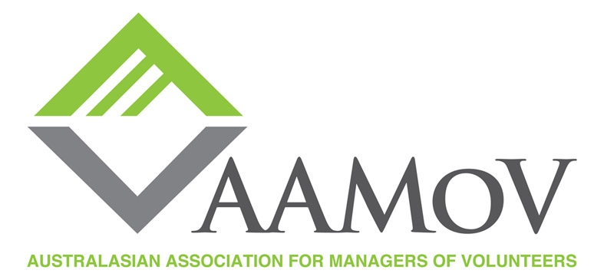

2015 Volunteer Manager Award of Excellence

Each year, the Australasian Association for Managers of Volunteers (AAMoV) recognises managers of volunteers for their outstanding contributions to the profession of volunteer management and the promotion of quality volunteerism in the community. Any individual or team who manages or coordinates volunteers in a public, corporate or non-profit organisation is eligible and can be nominated. Self-nominations are also accepted.

Volunteer Managers can be nominated for one of two awards:

- An individual award (one person)
- A group or team award (a group of people)

Nomination Guidelines:

- The questions noted below must all be answered for the nominee to be considered
- Attachments and documents that provide additional clarity or solid examples of the information provided in the response may be included
- Each application must include at least one letter of support from the organisation’s leadership (i.e. Chief Executive Officer, Executive Director, General Manager or Board Chairperson)
- Please provide a photo and bio of the nominee to put on the AAMoV website, so that they can be congratulated for their commitment to the sector
- All nominees will receive a certificate of recognition to highlight and acknowledge their contribution to this sector
- This year applications open 1 July and close 18 September
- Applications are to be sent via email to: aamovawardscommittee@gmail.com – see below for more information.

Nominee Information:

Nominee’s name:

Position/Title:

Organisation:

Address:

State/ Region:

Country:

Post code:

Phone:

Alternate phone number:

E-mail address:

Nomination Information:
Indicate which award is being nominated (Individual or Group):

Approximate number of years the nominee/s has been in the profession of volunteer management:

Is the nominee/s an AAMoV member? (Yes/No):

Each question below must be addressed concisely, but comprehensively, as this information is crucial in assisting the judges to gain a good understanding of the nominee/s work and its impact and as such reach a final decision. Please ensure all questions are answered.

- Describe the nominee/s accomplishments as a volunteer manager/coordinator in their present and/or previous positions. What has been the impact of the accomplishments? (25 points) – a maximum of 300 words

- In what ways has the nominee/s been a role model or mentor for other volunteer managers/coordinators? (15 points) – a maximum of 300 words

- Describe the nominee/s leadership role in the profession. What impact has their professional activities had in the field of volunteer management? (25 points) – a maximum of 300 words

- What unique characteristics make this nominee/s outstanding? (10 points) – a maximum of 300 words

- How does your nominee/s practice the belief that volunteers can make a significant contribution to the community? Please expand on specific examples that demonstrate this philosophy. (25 points) – a maximum of 300 words

Nominator information:

Nominators Name:

Position/Title:

Organisation:

Address:

State/ Region:

Country:

Post code:

Phone:

Alternate phone number:

E-mail address:

Nominator’s Signature:

Is the nominator an AAMoV member? (Yes/No):

If no, is the nominator agreeable to receiving information from AAMoV? (Yes/No):

Please indicate if you wish to remain anonymous (Yes/No):

An email will be sent to all nominees following the outcome of the judging panel and the winner will be announced on November 5 – International Volunteer Managers Day

For more information or if you have any questions: please contact: Alison Marshall (New Zealand based) on
0064 3 355 4314 or by email at aamovawardscommittee@gmail.com

Applications are due by 18 September to: Alison, email: aamovawardscommittee@gmail.com

A confirmation email will be sent within 5 working days of receipt of the nomination.

